******GALGOTIAS UNIVERSITY

Plot No.2, Sector -17 A, Yamuna Expressway,

Greater Noida, Gautam Buddh Nagar, U.P., India

**SCHOOL OF COMPUTING SCIENCE & ENGINEERING**

CAT-3 Case Study Report File Submission

On

“P-N JUNCTION DIODE”

Course Name: BEEE

Course Code: BEE01T1003

School: SCSE

Program: B.Tech

Year: 1st Semester: 1

Session: 2020-2021

|  |  |
| --- | --- |
| Submitted By: | Submitted To: |
| PRIYANSHU BIR  20SCSE1010743  VIRENDAR KUMAR  20SCSE1010749 | Prof. Jeba Das |

**ABSTRACT**

A PN Junction Diode is one of the simplest semiconductor devices around, and which has the characteristic of passing current in only one direction only. However, unlike a resistor, a diode does not behave linearly with respect to the applied voltage as the diode has an exponential current-voltage ( I-V ) relationship and therefore we cannot described its operation by simply using an equation such as Ohm’s law.

**CONTENT**

1. INTRODUCTION
2. REPRESENTATION
3. WORKING
4. FORWARD BIASING
5. REVERSE BIASING
6. I-V CHARACTERISTICS
7. APPLICATIONS
8. REFRENCES

**INTRODUCTION**

A p-n junction diode is two-terminal or active semiconductor device, which allows the electric current in only one direction while blocks the electric current in opposite or reverse direction.

**REPRESENTATION**

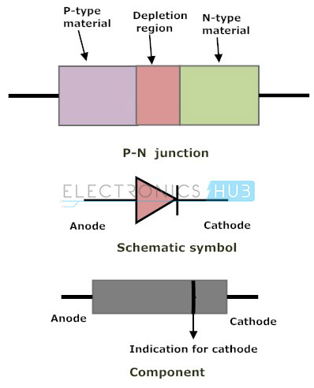

**WORKING**

A diode (PN junction) in an electrical circuit allows current to flow more easily in one direction than another. Forward biasing means putting a voltage across a diode that allows current to flow easily, while reverse biasing means putting a voltage across a diode in the opposite direction. The voltage with reverse biasing doesn't cause any appreciable current to flow. This is useful for changing AC current to DC current. It has other uses in manipulating electronic signals as well.

**FORWARD BIASING**

When the voltage is applied in the opposite direction across the diode, the depletion region begins to shrink. In a reverse-biased diode, the electrons and holes would be pulled away from the junction, but a forward-biased scenario ensures that the electrons and holes move toward the junction as they are repelled from the positive and negative terminals of the voltage source respectively. Given a great enough applied voltage, both the holes and the electrons would overcome the depletion region and meet near the junction, where they could combine in a continuous process, closing the circuit and allowing current flow.

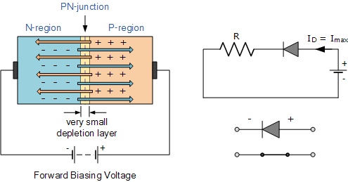

**REVERSE**

If a voltage is applied across the diode in such a way that the n-type half of the diode was connected to the positive terminal of the voltage source and the p-type half was connected to the negative terminal, electrons from the external circuit would create more negative ions in the p-type region by "filling the holes" and more positive ions would be created in the n-type region as electrons are displaced toward the positive terminal of the voltage source. Hence, the depletion region would increase and the voltage between the p-type and n-type regions would also increase as the total charge on each side of the junction increases in magnitude until the voltage across the diode equals and opposes the applied voltage and cancels it out, ceasing the current through the circuit. This process happens nearly instantaneously and results in essentially no current flow through the circuit when voltage is applied in this direction across the diode. This is known as a reverse-biased p-n junction.

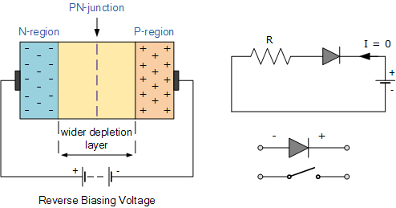

**I-V CHARATERISTICS AND TERMINILOGY**

**Forward Voltage and Breakdown Voltage**

There is a minimum threshold voltage required to overcome the depletion region, which for most silicon diodes is a significant 0.7 volts.

Furthermore, reverse-bias voltage does induce a small amount of current through the diode called leakage current that is essentially negligible for most purposes.

Finally, a great enough reverse voltage will result in the complete electronic breakdown of the diode and allow current to flow through the diode in the reverse direction.

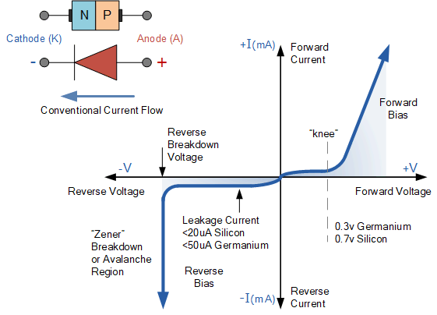

**APPLICATIONS**

* Rectification: The conversion of alternating current into direct current is known as rectification. A p-n junction diode allows electric current when it is forward biased and blocks electric current when it is reverse biased. This action of p-n junction diode enables us to use it as a rectifier.
* Diodes are used as switch in digital logic circuits used in computers.
* Diodes are used in demodulation circuits.
* Laser diodes are used in optical communications.
* Light Emitting Diodes (LEDs) are used in digital displays.
* Diodes are used in voltage regulators.

**REFERENCES**

* [**https://ndl.iitkgp.ac.in/**](https://ndl.iitkgp.ac.in/)
* [**https://www.electronics-tutorials.ws/**](https://www.electronics-tutorials.ws/)